Press release
Leuven, Belgium, 8 November 2011

New and Revised Extensions for Accessible Document Creation with OpenOffice.org and LibreOffice
The Katholieke Universiteit Leuven (K.U.Leuven) today released an extension for OpenOffice.org Writer and LibreOffice Writer that enables users to evaluate and repair accessibility issues in word processing documents. “AccessODF” (http://sourceforge.net/p/accessodf/wiki/) is a freeware extension for OpenOffice.org and LibreOffice, two office suites that are freely available for Microsoft Windows, Mac OS X, Linux/Unix and Solaris. At the same time, K.U.Leuven also releases new versions of two other extensions: odt2daisy (http://odt2daisy.sourceforge.net/) and odt2braille (http://odt2braille.sourceforge.net/). The former enables users to export word processing documents to digital talking books in the DAISY format; the latter enables exporting to Braille and printing on a Braille embosser.
AccessODF, odt2daisy and odt2braille are being developed in the framework of the AEGIS project, an R&D project funded by the European Commission. The three extensions will be demonstrated at the AEGIS project’s Workshop and Conference, which take place in Brussels on 28-30 November 2011 (http://aegis-conference.eu/).

AccessODF
AccessODF is an extension that can be used in OpenOffice.org Writer and in LibreOffice Writer. It enables authors to find and repair accessibility issues in their documents, i.e. issues that make their documents difficult or even impossible to read for people with disabilities. This includes issues such as:
- insufficient colour contrast between text and background,
- missing text alternatives for images and other objects (such text alternatives are necessary for blind users and other users of text-to-speech software),
- missing language identification for the document and for language changes inside the document (language information is needed for conversion into Braille and synthetic speech),
- the use of proper Heading styles instead of big bold text to identify headings (this enables document navigation based on headings),
- the use of proper tables instead of visually mimicking tables by using tabs or spaces,
- the compatibility of images with DAISY, the de-facto standard for digital talking books.
The AccessODF extension displays its list of errors and warnings in a panel next to the main authoring area (see Illustration 1, below).
For each accessibility issue, AccessODF provides a description and repair suggestions. Authors can repair the issues and recheck the document by pressing the Check button. For some issues, authors can simply press the Repair button to fix the issue automatically. For some other issues, pressing the Repair button guides authors to the appropriate dialog where they can fix the issues themselves. For all remaining issues, they can follow the instructions provided in the repair suggestions. If AccessODF lists an issue that is not an accessibility issue, authors can press the Ignore button.
Making Writer documents more accessible is not only important for users of Writer, but also for users of formats that Writer can export, for example PDF, XHTML, and – through extensions – DAISY and Braille. Accessibility evaluation and repair for Writer documents is a feature frequently requested by users of odt2daisy and odt2braille.
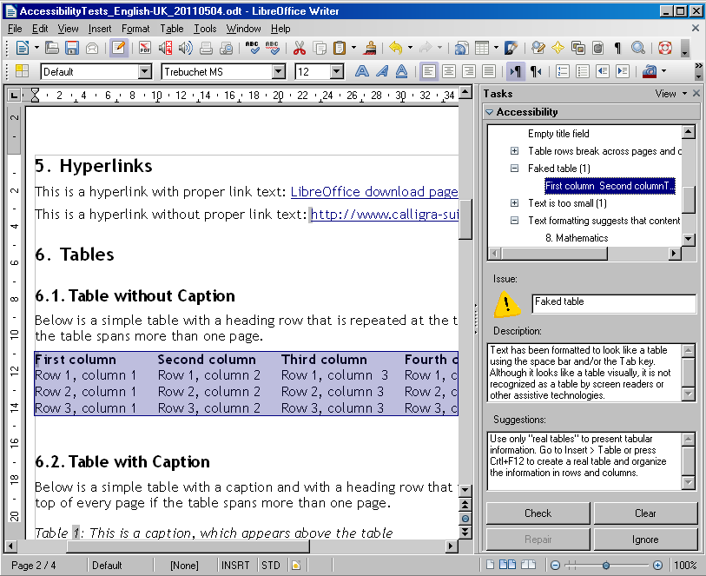Illustration 1: AccessODF identifying several accessibility issues in a test document

odt2daisy
odt2daisy is an extension that converts Writer documents into digital talking books in the DAISY format. It supports several versions of DAISY: not only the current version – DAISY 3.0 – but also the version DAISY 2.02 for compatibility with older DAISY players. odt2daisy supports Mathematical Markup Language (MathML) and multilingual documents. It uses the text-to-speech engines installed in the user's operating system for speech synthesis.
odt2daisy was first released in November 2009. The new release includes many small improvements such as:
- better support for tables and table captions,
- better support for long text alternatives (“long descriptions”) for images,
- better support for multilingual documents and non-Western languages,
- preventing the use of incorrect bitrates for text-to-speech conversion,
- better handling of title pages.
Many of these changes resulted from co-operation with a Flemish Braille and DAISY conversion centre.
odt2daisy is available for Microsoft Windows, Mac OS and Linux and can be downloaded from http://odt2daisy.sourceforge.net/.

odt2braille
odt2braille is an extension that converts Writer documents into Braille or prints them on a Braille embosser. odt2braille was first released in August 2010. The new release includes numerous improvements, such as:
- support for a larger number of Braille embossers,
- support for a larger number of languages,
- expanded Braille formatting settings for professional users: volume management, tables, footnotes, pictures, etcetera,
- user interface localisation in other languages, e.g. Czech and Polish,
SourceForge selected odt2braille as “SourceForge Project of the Month” in April 2011: http://sourceforge.net/blog/april-project-of-the-month-odt2braille/.
odt2braille can be downloaded from http://odt2braille.sourceforge.net/.
At the time of writing, odt2braille is only available on Microsoft Windows. It will later become available as a Debian package prepared by the Debian Accessibility Project (http://www.debian.org/devel/debian-accessibility/). Mac users can try out a limited beta version (which does not have the print functionality, and has only been tested on Mac OS Leopard).

Open-Source Software
AccessODF, odt2braille, odt2daisy and most other software developed in the ÆGIS project are or will be available as “open-source software”. This means that users will not only be able to download the finished product but also the programming code or “source code”. They can also modify and improve the source code, provided that they make their changes available to the developers or the community that maintains the software. This process enables a community of users to make improvements to the software and enables these improvements to be quickly available to other users.

About OpenOffice.org and LibreOffice
Several partners in the ÆGIS project are making contributions to OpenOffice.org and LibreOffice, including Katholieke Universiteit Leuven (Belgium), DART and FPD (both from Sweden). The OpenOffice.org Community (http://www.openoffice.org/) is an international team of volunteer and sponsored contributors who develop, translate, support, and promote the leading open source office productivity suite, OpenOffice.org. UNO, OpenOffice.org’s language-independent Application Programming Interface (API) is also available for developers, systems integrators, etcetera to use in OpenOffice.org extensions or in their own applications.
OpenOffice.org uses the OpenDocument Format OASIS Standard (ISO/IEC 26300) as well as supporting legacy file formats such as Microsoft Office, and is available on major computing platforms in over 100 languages. OpenOffice.org software was provided under the GNU Lesser General Public License (LGPL) until June 2011 and may be used free of charge for any purpose, private or commercial. OpenOffice.org development is expected to continue at the Apache Software Foundation (ASF) under the Apache License.
LibreOffice (http://www.libreoffice.org/) is a free and open-source office suite based on the OpenOffice.org source code. It is a community-driven project of The Document Foundation. The Document Foundation was formed in September 2010 and has released several new versions of LibreOffice since that time. New code in LibreOffice is developed under a double license: the GNU Lesser General Public License Version 3 or any later version (LGPLv3+) and the Mozilla Public License (MPL).

ÆGIS Project

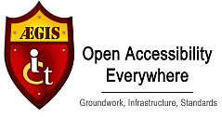
http://www.aegis-project.eu/

